SIMATS ENGINEERING
ASSESSMENT TOOL 1

COURSE NAME: OBJECT ORIENTED ANALYSIS AND DESIGN COURSE CODE: CSA1102

COURSE OUTCOME COVERED
CO2: Design UML diagrams to represent system requirements and architecture. (BL3)
Assessment Tool Weightage: 40%

Course Faculty: Dr R Dhanalakshmi
QUESTIONS: Any 4 Total Marks:40
Annexure A

ANALYTICAL PROBLEM SOLVING

Code of Conduct:
I B.Amar(192421397)_ (Name / Reg No) certify that this submission is my original work and that I have adhered to the guidelines specified for this assessment.
I understand that any violation of academic integrity rules will result in disciplinary action.

Signature of the student: b.amar

Question 1: Use Case Diagram – Smart Banking System (10 Marks)

Problem: A Smart Banking System allows customers to create accounts, transfer funds, pay bills, and view transaction history. Bank employees verify customer details, while administrators manage user accounts and banking services. Requirements are only partially documented.

Actors involved in the system

Actor | Type | Role in the system
Customer | Primary | Creates an account, transfers funds, pays bills and views transaction history.
Bank Employee | Primary | Verifies the customer details submitted while an account is created.
Administrator | Primary | Manages user accounts and the banking services offered by the bank.
Bank Staff | Abstract | Generalised actor; Bank Employee and Administrator both inherit from it (both are internal staff).
Payment Gateway | Secondary (external) | External system / biller network that settles the bill payments initiated by the customer.

Primary use cases

Use case | Actor(s) | Description
Create Account | Customer | Customer registers and opens a new bank account.
Verify Customer Details | Bank Employee | Employee checks identity / KYC documents of the applicant.
Transfer Funds | Customer | Moves money from one account to another (internal or external).
Pay Bills | Customer, Payment Gateway | Pays utility and other bills through the gateway.
View Transaction History | Customer | Displays past debits and credits of an account.
Manage User Accounts | Administrator | Creates, blocks, unblocks, updates or deletes user accounts.
Manage Banking Services | Administrator | Configures products and services (limits, charges, interest, etc.).
Authenticate User | (common) | Login with password / OTP before any secure operation.
Send SMS / Email Alert | (optional) | Notifies the customer about a transaction.
Download Statement | Customer | Exports the transaction history as a statement.

Relationships

Type | From | To | Reason
«include» | Create Account | Verify Customer Details | An account can never be opened without verification of details.
«include» | Transfer Funds, Pay Bills, View Transaction History, Manage User Accounts | Authenticate User | Every secure operation must always authenticate the user first.
«extend» | Send SMS / Email Alert | Transfer Funds | The alert is sent only when the customer has opted in.

Use Case Diagram – Output
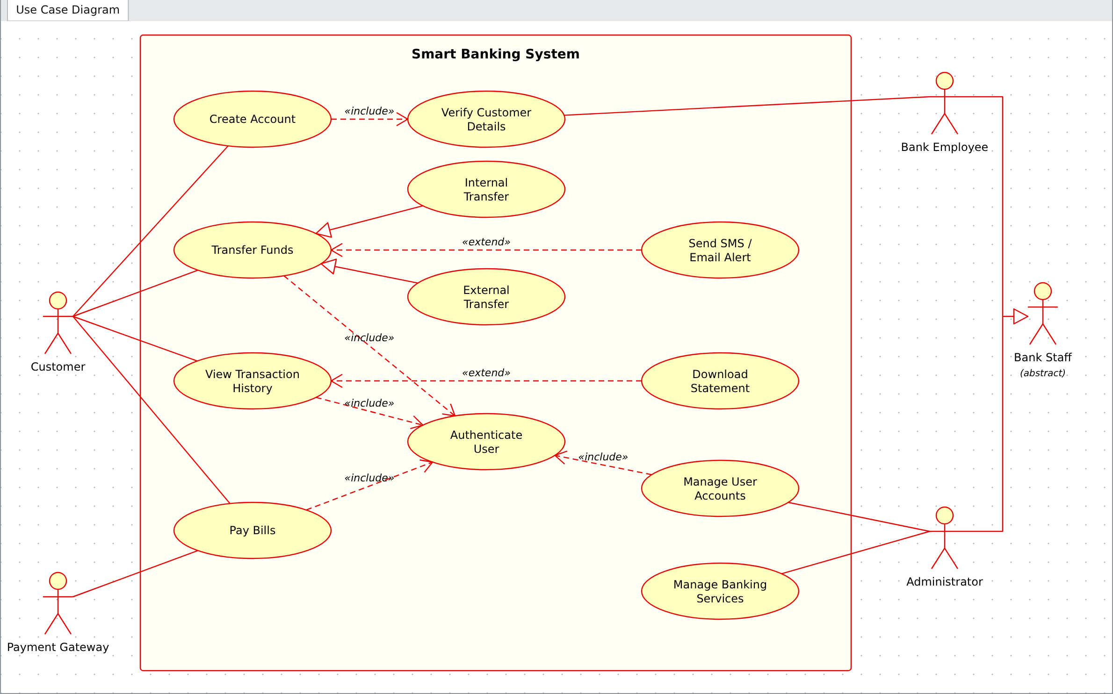
Figure 1: Use Case Diagram of the Smart Banking System

Question 2: Class Diagram – Online Vehicle Rental System (10 Marks)

Problem: An Online Vehicle Rental System consists of entities such as Vehicle, Customer, Reservation, Payment, and RentalAgent. The relationships among these entities have not been clearly defined.

Classes with attributes and methods

Class | Attributes | Methods
Person (abstract) | - userId : String  - name : String  - email : String  - phone : String | + login() : boolean  + logout() : void
Customer | - licenseNo : String  - address : String | + register()  + searchVehicle()  + makeReservation()  + cancelReservation()
RentalAgent | - employeeId : String  - branch : String | + confirmReservation()  + handoverVehicle()  + receiveVehicle()
Vehicle (abstract) | - vehicleId : String  - registrationNo : String  - brand : String  - model : String  - rentPerDay : double  - status : String | + checkAvailability() : boolean  + updateStatus(s : String)  + calculateRent(days : int) : double
Car / Bike / Truck | Car: seats, fuelType  Bike: engineCC, hasHelmet Truck: loadCapacity, axles | getSeats(), getEngineCC(), getLoadCapacity()
Reservation | - reservationId : String  - startDate : Date  - endDate : Date  - status : String  - totalAmount : double | + createReservation()  + cancelReservation()  + calculateTotal() : double  + extend(days : int)
Payment | - paymentId : String  - amount : double  - paymentDate : Date  - method : String  - status : String | + processPayment() : boolean  + refund()  + generateReceipt()

Relationships

Relationship | Type | Explanation
Person ← Customer, RentalAgent | Inheritance | Customer and RentalAgent are kinds of Person and share userId, name, email, phone, login() and logout().
Vehicle ← Car, Bike, Truck | Inheritance | Specialised vehicles inherit common vehicle data and add their own attributes.
Customer – Reservation | Association ("makes") | A customer makes reservations.
RentalAgent – Reservation | Association ("confirms") | An agent confirms and hands over reserved vehicles.
Reservation ◇— Vehicle | Aggregation ("reserves") | A reservation refers to a vehicle, but the vehicle exists independently of the reservation.

Relationship | Type | Explanation
Reservation ◆— Payment | Composition ("is paid by") | A payment has no meaning without its reservation; deleting the reservation deletes its payments.

Multiplicity

Association | Multiplicity | Meaning
Customer — Reservation | 1 : 0..* | One customer can make zero or many reservations; each reservation belongs to exactly one customer.
RentalAgent — Reservation | 1 : 0..* | One agent handles many reservations; each reservation is confirmed by one agent.
Reservation — Vehicle | 0..* : 1 | A vehicle can appear in many reservations over time; a reservation books exactly one vehicle.
Reservation — Payment | 1 : 1..* | A reservation has one or more payments (advance + final); each payment belongs to one reservation.

Class Diagram – Output
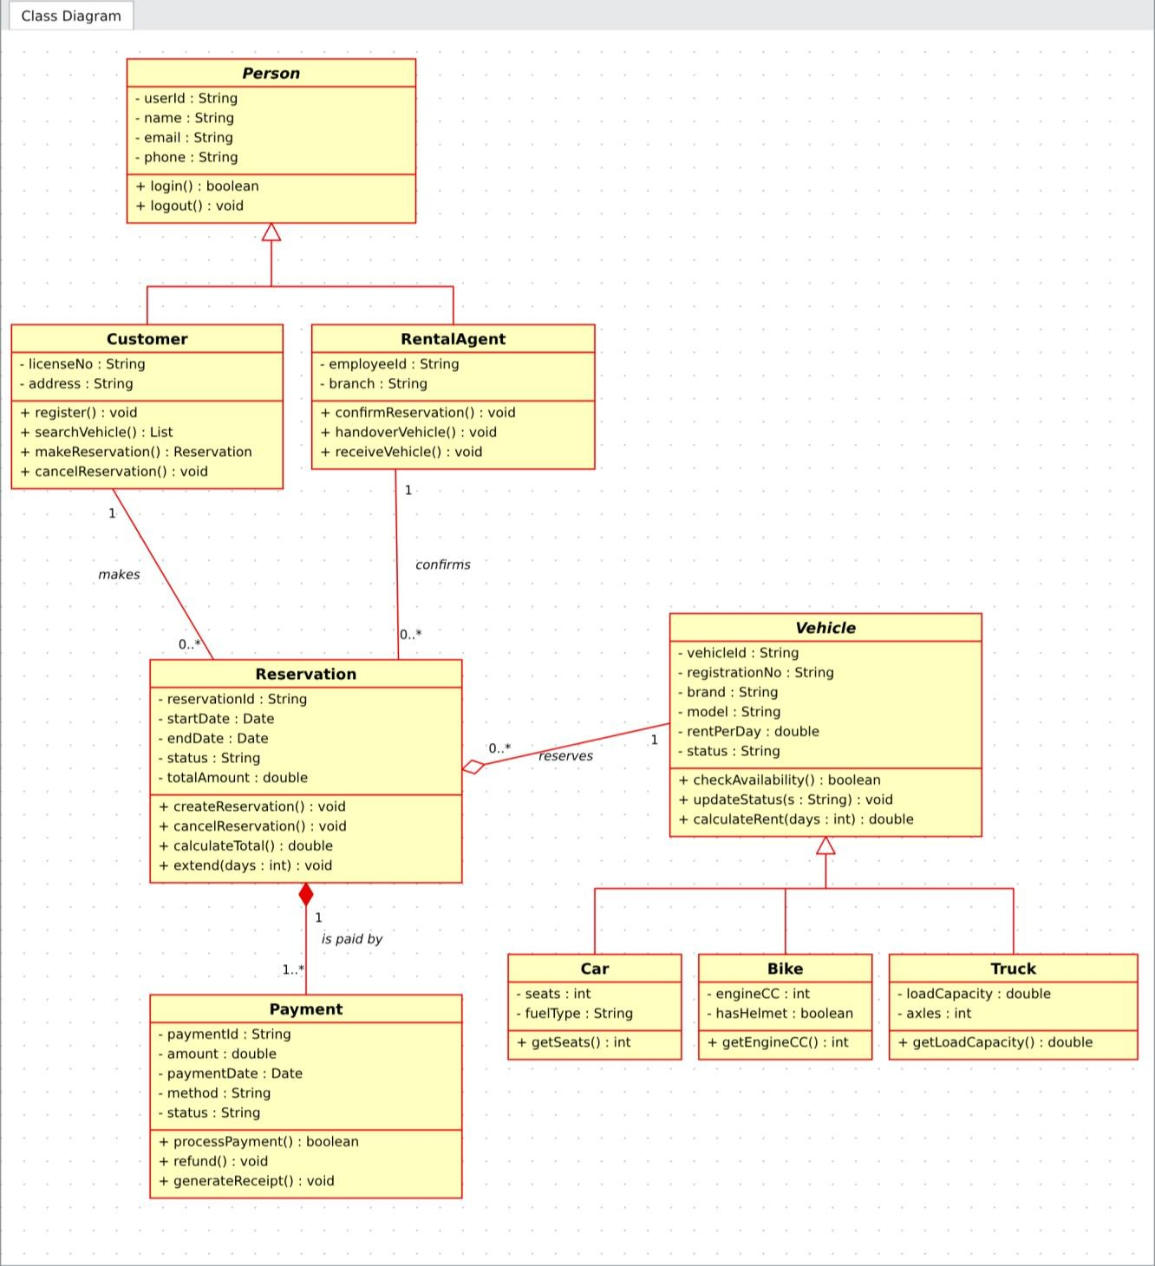
Figure 2: Class Diagram of the Online Vehicle Rental System

Question 3: Sequence Diagram – E-Commerce Shopping System (10 Marks)

Problem: An E-Commerce Shopping System allows a customer to browse products, add items to the cart, place an order, make payment, and receive order confirmation. The sequence of interactions is unclear.

Objects participating in the interaction

Object | Responsibility
Customer (actor) | Starts the interaction: browses, adds to cart, places the order.
:ShoppingUI | Web / mobile interface; receives user requests and shows results.
:ProductCatalog | Holds product details and stock information.
:ShoppingCart | Stores the selected items and quantities.
:OrderManager | Creates the order, coordinates payment and updates order status.
:PaymentGateway | Authorises and processes the payment.
:NotificationService | Sends the order confirmation by e-mail / SMS.

Message flow

No. | From → To | Message
1–4 | Customer → UI → Catalog | browseProducts(), getProducts(), return productList, displayProducts()
5–10 | Customer → UI → Cart → Catalog | addToCart(productId, qty), addItem(), checkStock(), return stockAvailable, cartUpdated, showCart()
11–14 | Customer → UI → OrderManager → Cart | placeOrder(), createOrder(cartId), getCartItems(), return itemList
15–16 | OrderManager → PaymentGateway | processPayment(amount, cardDetails), return paymentStatus
17–21 | ALT [payment successful] | updateOrderStatus("Confirmed") (self message), sendConfirmation(orderId), confirmation e-mail / SMS to customer, orderConfirmed, displayConfirmation()
22–23 | ALT [payment failed] | paymentFailed, showErrorMessage()

Activation bars and lifelines
  - Each object has a dashed vertical lifeline that represents its existence over time (time flows downwards).
  - A narrow rectangle on a lifeline is an activation bar: it shows the period in which the object is executing a request. It starts when a message arrives and ends when the reply is returned.
  - Solid arrows with filled heads are synchronous calls; dashed arrows with open heads are return messages.
  - Message 17 is a self message (OrderManager calls its own operation). The "alt" combined fragment separates the success and failure paths.

Sequence Diagram – Output
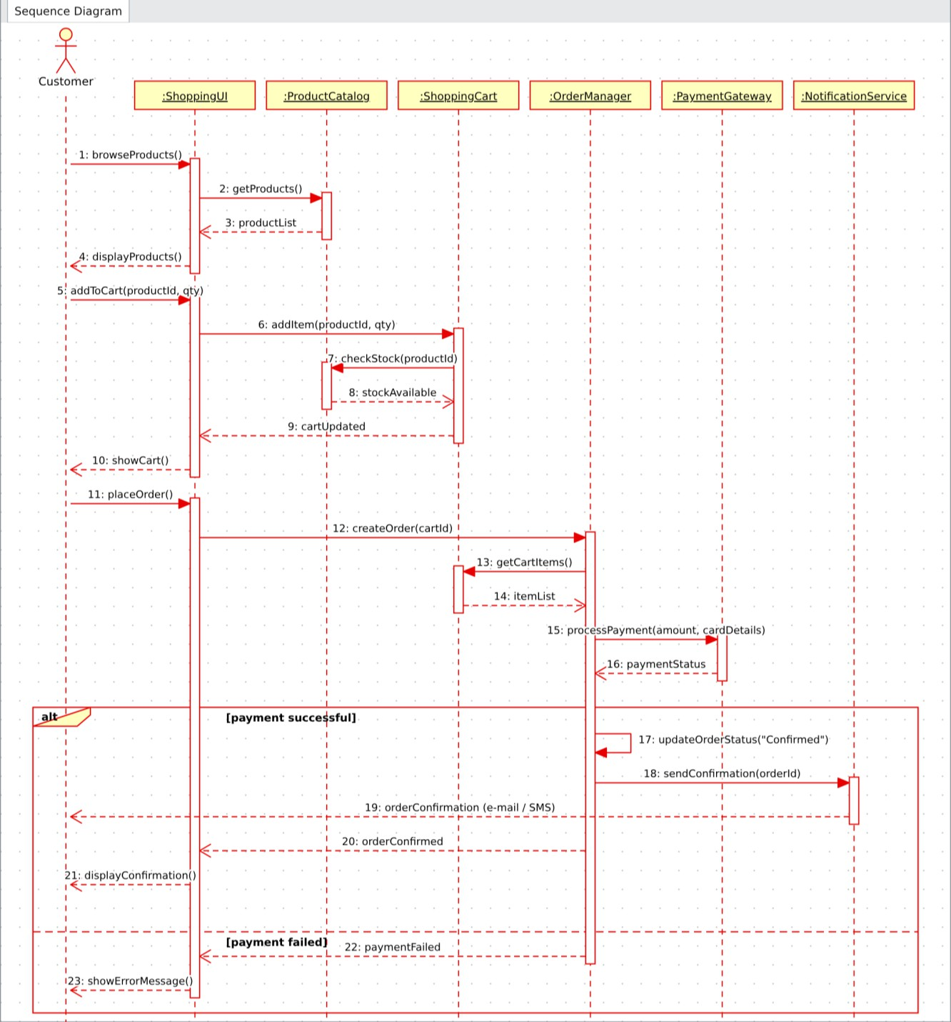
Figure 3: Sequence Diagram of the E-Commerce Shopping System

Question 4: Activity Diagram – Job Recruitment Portal (10 Marks)

Problem: A Job Recruitment Portal enables applicants to register, upload resumes, apply for jobs, attend interviews, and receive offer letters. Recruiters verify applications before scheduling interviews. The business workflow needs optimization.

Activities in the recruitment workflow
Register on Portal → Upload Resume, Update Profile Details, Browse Job Listings → Apply for Job → Verify Application (Recruiter) → Schedule Interview, Send Interview Invitation → Attend Interview → Evaluate Candidate → Generate Offer Letter, Update Application Status → Send Offer Letter to Applicant. Rejected candidates receive a Rejection Notice.

Decision nodes

Decision | Guard | Outcome
Valid? (after Verify Application) | [valid] | Interview scheduling begins.
 | [invalid] | Send Rejection Notice → end of the process.
Selected? (after Evaluate Candidate) | [selected] | Offer letter is prepared and sent.
 | [rejected] | Send Rejection Notice → end of the process.

Parallel activities (fork and join)
  - Fork 1: Upload Resume, Update Profile Details and Browse Job Listings can be done in any order at the same time.
  - Fork 2: Schedule Interview and Send Interview Invitation run together after a successful verification.
  - Fork 3: Generate Offer Letter and Update Application Status run together after selection.

Optimizations made to the workflow
  - Independent applicant tasks are done in parallel, so registration-to-application time is reduced.
  - Invalid applications are rejected early, before any interview effort is spent.
  - Scheduling and invitation are merged into one parallel step, avoiding manual hand-offs.
  - Offer generation and status update happen together so the portal always shows the latest state.

Activity Diagram – Output
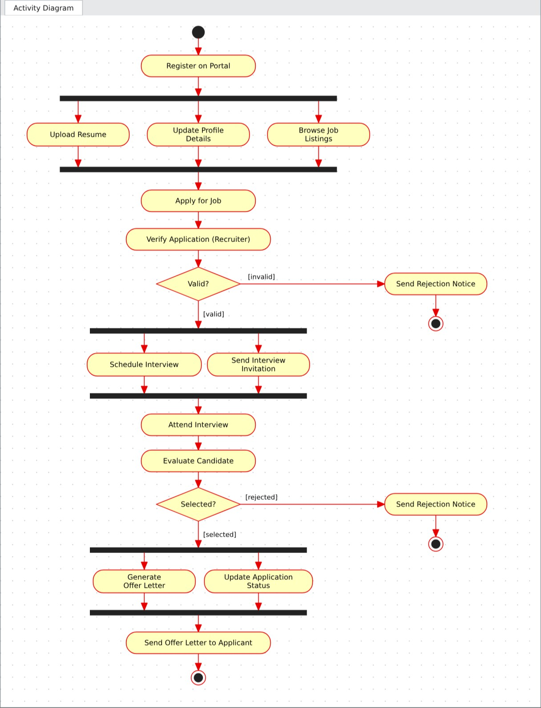
Figure 4: Activity Diagram of the Job Recruitment Portal

Question 5: State Diagram – Smart Parking Management System (10 Marks)

Problem: A Smart Parking Management System operates through states such as Parking Slot Available, Vehicle Entered, Parking Allocated, Payment Pending, Payment Completed, and Vehicle Exited. The behaviour during parking operations needs to be modelled.

States of the system

State | Description
Parking Slot Available | Slot is free and shown as available on the display.
Vehicle Entered | Entry sensor has detected a vehicle; number plate is read.
Parking Allocated | A free slot is assigned and a ticket is issued.
Payment Pending | Vehicle wants to leave; parking fee is calculated and awaited.
Payment Completed | Fee is paid and a receipt is printed.
Vehicle Exited | Exit gate opens and the vehicle leaves.

Events triggering state transitions

From state | Event [guard] / action | To state
Parking Slot Available | vehicleDetected() [entry sensor ON] | Vehicle Entered
Vehicle Entered | slotAssigned() [free slot found] / issueTicket() | Parking Allocated
Vehicle Entered | timeout / entryCancelled() | Parking Slot Available
Parking Allocated | exitRequested() / scanTicket() | Payment Pending
Payment Pending | paymentFailed() / retry | Payment Pending (self transition)
Payment Pending | paymentSuccess() / printReceipt() | Payment Completed
Payment Completed | gateOpened() / vehicle exits | Vehicle Exited
Vehicle Exited | slotReleased() / updateDisplay() | Parking Slot Available
Parking Slot Available | shutDown() | Final state

Initial and final states
  - Initial state: the filled black circle; systemStart() moves the system into Parking Slot Available.
  - Final state: the bull’s-eye circle; reached from Parking Slot Available on shutDown().
  - After Vehicle Exited the system returns to Parking Slot Available, so the parking cycle repeats for the next vehicle.

State Diagram – Output
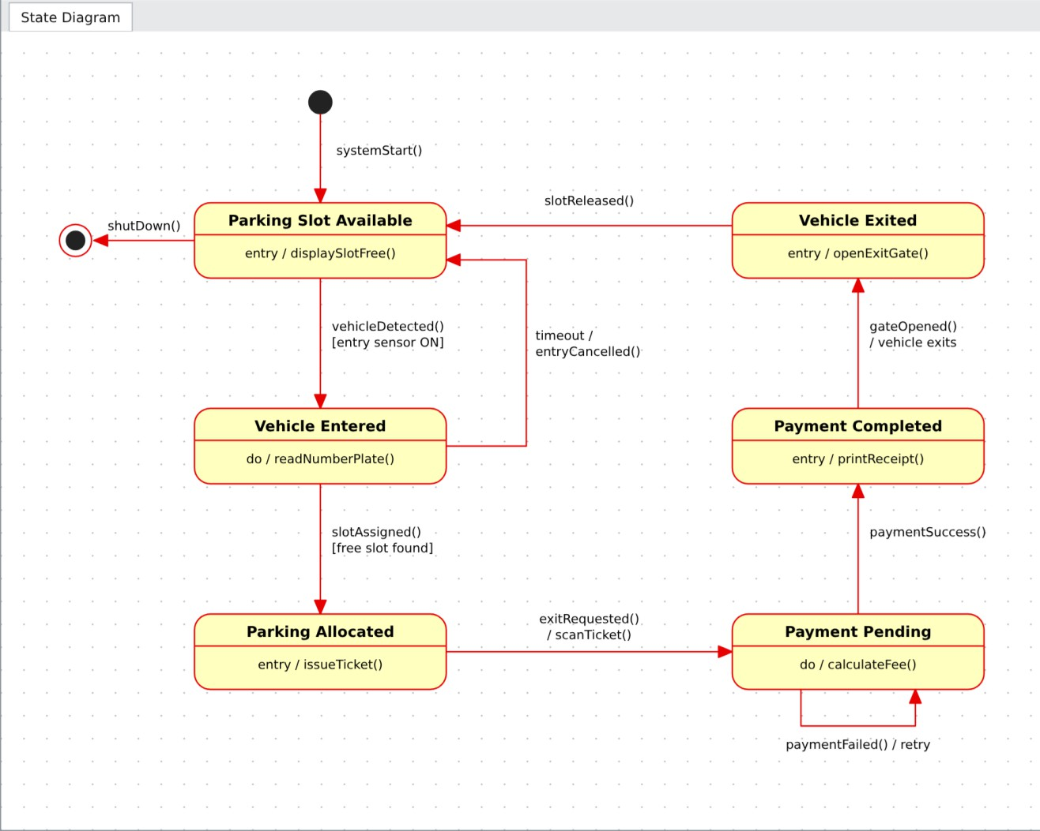
Figure 5: State Transition Diagram of the Smart Parking Management System

Question 6: Deployment Diagram – Smart Agriculture Monitoring System (10 Marks)

Problem: A Smart Agriculture Monitoring System uses IoT sensors to monitor soil moisture, temperature and humidity. Data is sent to a cloud platform where farmers monitor crops through a mobile app. Automated irrigation starts when soil moisture falls below a predefined threshold.

Hardware nodes

Node | Stereotype | Purpose
Soil Moisture Sensor | «device» | Measures moisture level of the soil.
Temperature Sensor | «device» | Measures field temperature.
Humidity Sensor | «device» | Measures relative humidity.
IoT Gateway (ESP32 Microcontroller) | «device» | Collects sensor readings and sends them to the cloud.
Cloud Platform (IoT Server) | «executionEnvironment» | Stores and processes data, applies the irrigation rule.
Farmer's Smartphone | «device» | Lets the farmer monitor crop conditions.
Irrigation Controller | «device» | Receives ON/OFF commands and drives the relay.
Water Pump / Solenoid Valve | «device» | Actuator that irrigates the field.

Software components deployed on each node

Node | Components / artifacts
IoT Gateway | Sensor Data Collector, MQTT Client Firmware
Cloud Platform | MQTT Broker, Data Ingestion Service, Irrigation Rule Engine (moisture < threshold), Time-Series Database, REST API / Notification Service, Authentication Service
Farmer's Smartphone | Mobile App (Android / iOS)
Irrigation Controller | Irrigation Control Firmware
Sensors, Pump | Hardware only (no deployed software component)

Communication links

Between | Link / protocol
Sensors ↔ IoT Gateway | Analog (ADC), 1-Wire and digital GPIO wiring
IoT Gateway ↔ Cloud Platform | Wi-Fi / 4G, MQTT over TLS
Cloud Platform ↔ Farmer's Smartphone | HTTPS / REST over 4G or Wi-Fi
Cloud Platform ↔ Irrigation Controller | MQTT over Wi-Fi (irrigation ON/OFF command)
Irrigation Controller ↔ Pump / Valve | Relay – wired connection

Deployment Diagram – Output
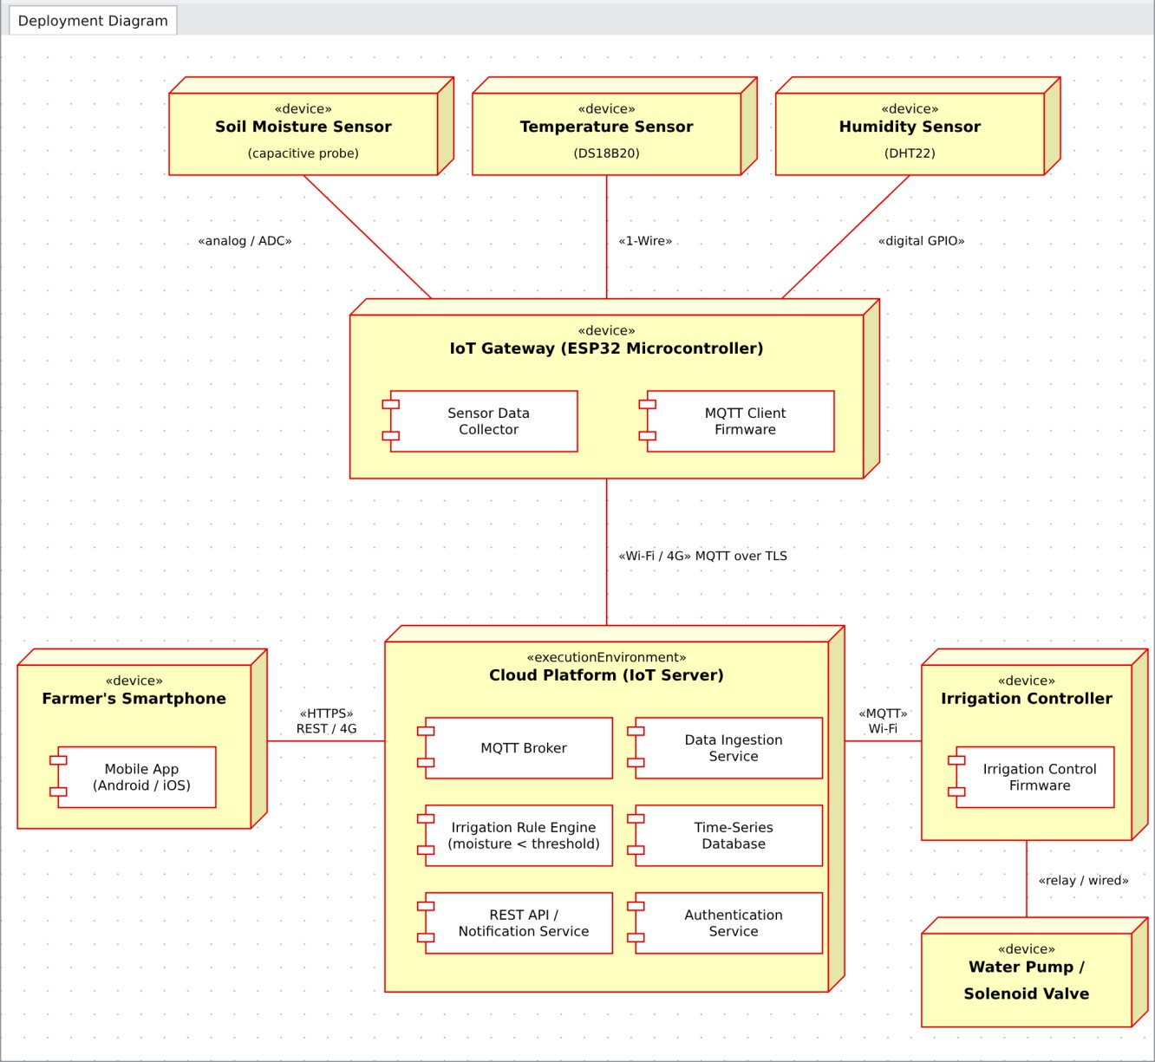
Figure 6: Deployment Diagram of the Smart Agriculture Monitoring System

